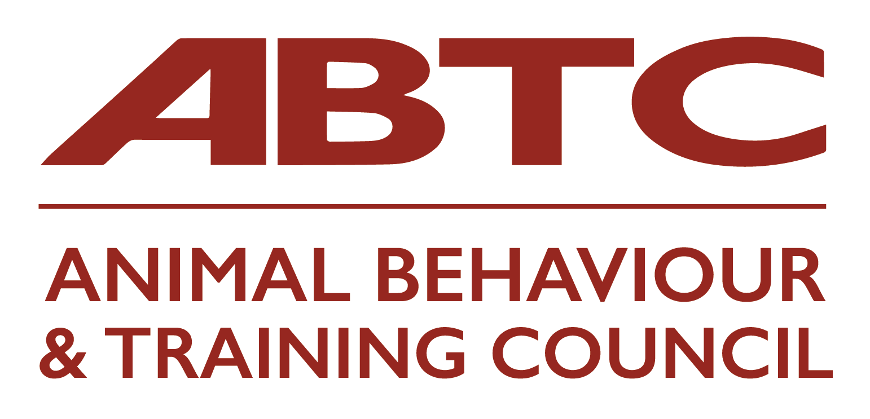
I would like to apply for APEL Assessment by ABTC

Name:
Email:
Telephone number:
Address:
Organisation you are applying to join:
Role applied for: (ABT/CAB)
I have included:
- Mapping document
- Reflective Accounts forms (the number of which may vary for each applicant)
- Any certificates/module descriptors etc. that are referred to in the documentation
- An index to the documents included in my application
Please sign to agree to the below:
I understand that my information will be handled in line with GDPR good practice and that my Practitioner Organisation will retain the documentation for the duration of my provisional/full membership with them.
I understand that my contact details and all information will be shared with the ABTC Assessors
I have read and understand the Guidelines for Applicants
I have paid a non-refundable fee of £120 to ABTC for this assessment*
I have provided my APEL documents to my Practitioner Organisation declare that the information given is a true and honest account of my experience
Signed
Date
*Non-refundable payment of £120 should be sent, via bacs, to:
Animal Behaviour & Training Council
Sort code: 30-92-79
Account no. 28617368

Reference on the bacs should be your name and ‘APEL’
Please also email admin@abtc.org.uk to let Val know you have paid. She will acknowledge receipt when it arrives in the account.

You will have been notified if your organisation also has an admin fee. This fee should be paid to your organisation and NOT to ABTC.

For office use only:
Date received:
Payment received:
Assessors allocated:
Additional interview:
Result:

